Project Design Phase-II
Technology Stack (Architecture & Stack)

Date | 31 January 3035
Team ID
Project Name
Maximum Marks | 4 Marks

Technical Architecture:
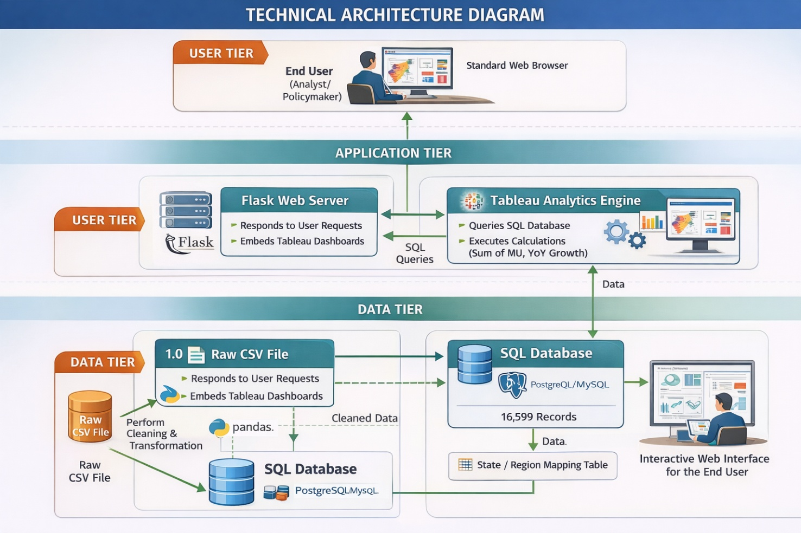

Table-1: Components & Technologies

S.No | Component | Description | Technology
1 | User Interface | Responsive web portal to host the analytical story and interactive maps. | HTML5, CSS3, Bootstrap 5
2 | Application Logic-1 | Data cleaning, preprocessing, and regional mapping of consumption records. | Python (Pandas/NumPy)
3 | Application Logic-2 | Web server logic to route requests and serve the embedded dashboard. | Flask (Python Framework)
4 | Database | Relational storage for 16,599 records to ensure high-speed querying and data integrity. | PostgreSQL / MySQL
5 | Data Visualization | Business Intelligence engine for rendering choropleth maps and time-series trends. | Tableau Public / Desktop
6 | File Storage | Storage of raw source datasets and project documentation. | Local Filesystem / GitHub
7 | External Interface | Integration of the Tableau dashboard into the web UI via iframe/JavaScript API. | Tableau JavaScript API
8 | Infrastructure | Hosting environment for the application and database. | Local Server (Development)

Table-2: Application Characteristics

S.No | Characteristics | Description | Technology
1 | Open-Source Frameworks | Utilized for data manipulation and web serving without licensing costs. | Python, Flask, Pandas
2 | Security Implementations | Use of parameterized SQL queries to prevent injection and secure embedding protocols. | SQL Alchemy, Werkzeug
3 | Scalable Architecture | A modular 3-tier architecture allows the database to scale independently of the UI. | 3-Tier Architecture
4 | Availability | Accessible via any modern web browser without needing specialized BI software. | Web-Based (Chrome/Edge)
5 | Performance | Database indexing on "Date" and "State" columns ensures charts render in under 2 seconds. | SQL Indexing & Query Optimization

Architecture Summary

• Backend: Python handles the heavy lifting of data transformation.
• Storage: The SQL database provides a structured "Source of Truth" for the electricity metrics.
• Frontend: Flask provides the professional "wrapper" that makes the complex Tableau analysis accessible to non-technical users through a simple URL.

